PUBLISH CSV FILE USING PYTHON
AND DEPLOY IN AWS
PYTHON-BASED CSV GENERATION AND CLOUD DEPLOYMENT

1. Project Overview
The Publish CSV File Using Python and Deploy in AWS project is a web application that generates CSV files on request, previews them in a browser dashboard and lets the user download them. It is built with Python and Flask and is designed as a self-contained educational project suitable for college-level demonstration.
The user enters a record count, the application validates it, writes a file named data.csv, and the dashboard shows the records in a table together with statistics and a numeric chart. Hosting on Amazon Web Services (AWS) is described as a proposed deployment path.

2. Abstract
CSV files are a standard way to exchange tabular data, but preparing them manually is repetitive, error-prone and hard to preview or share. This project addresses that gap with a browser-based tool in which a Flask backend uses Python’s csv module to generate records and a JavaScript dashboard displays and downloads them.
The implemented functionality is the local Flask application: input validation, CSV generation, data retrieval through REST-style endpoints, a table and chart view, and file download. The AWS deployment on EC2 or Elastic Beanstalk, with optional Amazon S3 storage, is a proposed extension and is described as a methodology rather than a completed deployment.

3. Introduction
A CSV file stores tabular data as plain text, one record per line with comma-separated fields. It is supported by spreadsheets, databases and programming languages, which makes it one of the most common formats for data exchange.
Python automates such tasks well, and Flask turns a Python script into a web application that anyone can use from a browser. Cloud platforms such as AWS then make the application reachable beyond a single computer.
This project combines these three ideas in one small, understandable application.

4. Problem Statement
Users who need CSV files face the following difficulties:
- Manual creation is slow and prone to formatting and typing errors.
- The same preparation work is repeated for every new file.
- Scripts require programming knowledge and a configured environment.
- There is no immediate preview, statistic or chart of the generated data.
- Sharing the file depends on separate tools such as e-mail.
There is a clear need for a simple web-based tool that generates, previews and serves CSV files from one dashboard.

5. Objectives
- Automate CSV generation using Python’s csv module.
- Provide a user-friendly web dashboard built with HTML, CSS and JavaScript.
- Accept a record count and validate it on the client and the server.
- Display generated records dynamically in a table.
- Show statistics such as total rows and columns, and a numeric chart.
- Support downloading the generated CSV file.
- Expose generation, retrieval and download as JSON-based Flask endpoints.
- Document a deployment workflow for AWS.
- Maintain a clean, modular code structure suitable for academic evaluation.

6. Scope of the Project

6.1 In Scope
- Local CSV generation with a header row and sample records.
- Dashboard with table, statistics, chart and download control.
- REST-style endpoints: GET /, GET /api/data, POST /api/generate, GET /api/download.
- Input validation and error messages.
- Testing plan with functional and boundary test cases.
- Proposed AWS deployment methodology.

6.2 Out of Scope
- CSV file upload (included only if implemented and verified).
- User authentication or multi-user accounts.
- Database storage and large-dataset handling.
- Persistent Amazon S3 storage in the current implementation.
- A completed and verified AWS deployment.

7. Existing and Proposed System

7.1 Existing System
CSV files are typically prepared by typing into a spreadsheet or by running a command-line script. The result must be opened in another tool to be checked and shared separately, so the effort is repeated and errors are found late.

7.2 Proposed System
The proposed system is a Flask web application. The user generates a file with one click, sees the data immediately as a table and chart, and downloads the file from the same page. The same code can later be hosted on AWS.

8. Hardware and Software Requirements

8.1 Hardware (Development)
- Any modern laptop or desktop computer (minimum 4 GB RAM recommended).
- Dual-core processor or better and a few hundred megabytes of free disk space.
- Internet connection for installing packages and accessing AWS.

8.2 Software
- Python 3 and Flask.
- Visual Studio Code (recommended editor).
- Modern web browser (Chrome, Edge, Firefox or Safari).
- Windows 10/11 for development; Linux proposed for AWS hosting.

9. Technology Stack
Layer | Technology
Language | Python 3
Backend framework | Flask (routing, JSON responses, file download)
Frontend | HTML5, CSS3, JavaScript (Fetch API)
Data handling | Python csv module, JSON
Tools | Visual Studio Code, Git and GitHub
Cloud (proposed) | AWS: EC2 or Elastic Beanstalk, optional Amazon S3
Testing (proposed) | pytest and manual browser testing

10. System Architecture
The application follows a client-server design. The browser dashboard sends HTTP and JSON requests to Flask endpoints, a Python CSV component reads and writes data.csv, and the response returns as JSON or as a file download. The AWS layer is shown separately because it is proposed and not part of the local implementation.
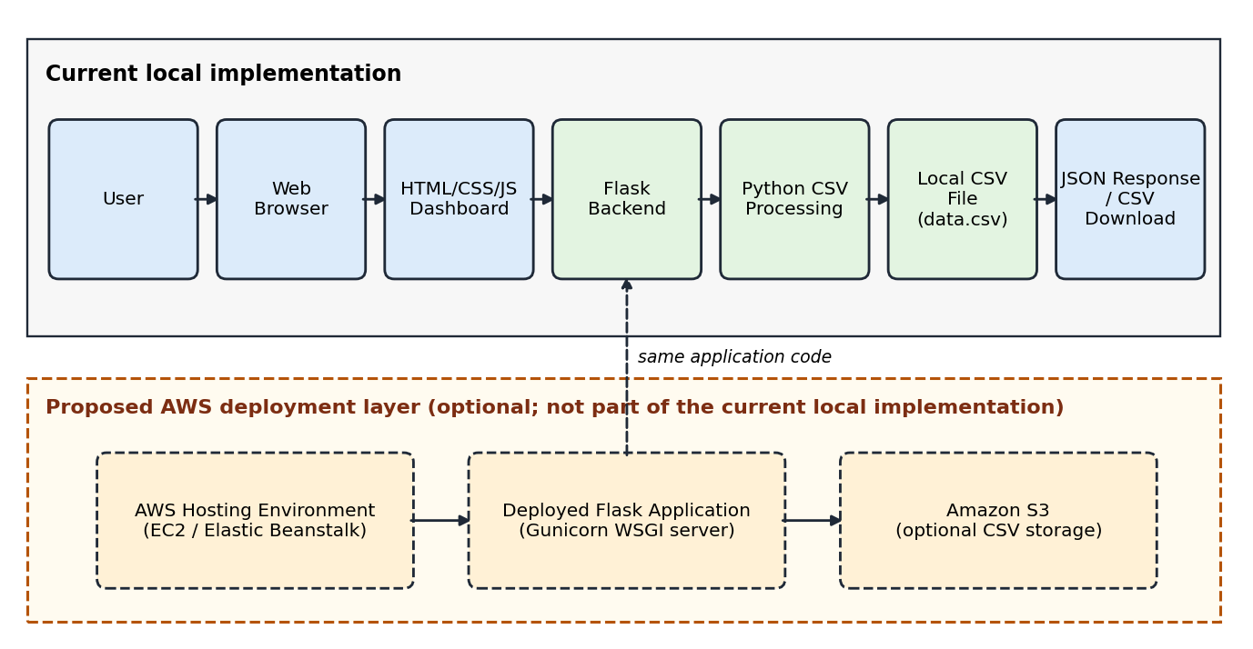
Figure 1: System architecture (AWS layer proposed)

11. Data Flow
- The user enters the number of records on the dashboard.
- JavaScript validates the value and sends a POST request to /api/generate.
- Flask validates the request and calls the CSV generation logic.
- Python writes the header and records to data.csv.
- A JSON confirmation is returned to the dashboard.
- The dashboard requests /api/data and refreshes the table, statistics and chart.

12. Use Case Description
Primary actor: User.
- Open the dashboard.
- Generate CSV data for a chosen record count.
- View records in the table.
- View statistics and the numeric chart.
- Download the CSV file.
The default configuration has no authentication; all users share one data.csv file.

13. Module Descriptions

13.1 Dashboard Module
Provides the gradient interface with the record count input, Generate button, statistic tiles, data table, chart, download control and status messages.

13.2 CSV Generation Module
Receives the count, writes the header row ID, Name, Value, Date, and then one sample record per row to data.csv, overwriting the previous file.

13.3 Input Validation Module
Rejects missing, non-numeric and out-of-range counts in the browser and again on the server, returning a clear error message.

13.4 Data Retrieval Module
Reads data.csv with csv.DictReader and returns the rows as JSON through GET /api/data.

13.5 Visualization Module
Renders table rows, updates the row and column counts and plots the numeric Value column.

13.6 CSV Download Module
Returns data.csv as an attachment through GET /api/download so the browser saves it.

13.7 Cloud Deployment Module (Proposed)
Describes hosting on AWS with a production WSGI server and optional S3 storage. It is a proposed extension.

14. CSV Structure and API Documentation

14.1 CSV Structure
Column | Meaning | Example
ID | Sequential record number | 1
Name | Record label | Sample 1
Value | Numeric field used in the chart | 100
Date | ISO 8601 date | 2026-10-17

14.2 API Endpoints
Method | Route | Purpose
GET | / | Serves the dashboard page
GET | /api/data | Returns the CSV rows as JSON
POST | /api/generate | Generates data.csv for the given count
GET | /api/download | Downloads data.csv

14.3 Sample Request and Response
POST /api/generate
Request: {"count": 5}
Response: {"message": "Generated 5 records", "count": 5}
Note: Check the routes and messages against the final source code before submission.

15. Testing and Test Cases
The test cases below are planned. Actual results remain pending until the tests are run.
ID | Scenario | Input | Expected result | Result
TC-01 | Dashboard loads | GET / | Page renders with controls | Pending
TC-02 | Valid generation | count = 5 | data.csv with 5 rows | Pending
TC-03 | Invalid text | count = abc | Error shown; no file written | Pending
TC-04 | Out of range | count = 0 or -3 | Rejected | Pending
TC-05 | Data retrieval | GET /api/data | JSON rows match the file | Pending
TC-06 | File download | GET /api/download | Browser saves data.csv | Pending
TC-07 | No file yet | Download first | 404 with message | Pending
TC-08 | Route matching | Frontend calls | No 404 for documented routes | Pending

16. Proposed AWS Deployment
This section is a plan. No deployment results, URLs or costs are claimed.
- Prepare the application: finalize app.py and requirements.txt, disable debug mode, push to GitHub.
- Launch an Amazon EC2 Linux instance (or create an Elastic Beanstalk environment).
- Install dependencies and run the app with a WSGI server such as Gunicorn.
- Configure the security group to allow HTTP or HTTPS and restrict SSH.
- Test the public endpoint with the checks from Chapter 15.
- Monitor logs and errors.
Optional S3 storage: generated files can be uploaded to an Amazon S3 bucket using an IAM role with least-privilege permissions, with public access blocked. Security: keep secrets out of source code, use environment variables and enable HTTPS.

17. Screenshots of the Working Application
Screenshots are not embedded in this document. Insert genuine screenshots of the following:
- [Insert screenshot: main dashboard]
- [Insert screenshot: CSV generation message]
- [Insert screenshot: data table with statistics]
- [Insert screenshot: numeric chart]
- [Insert screenshot: downloaded CSV file]
- [Insert screenshot: test results]

18. Results and Discussion
The application generates a CSV file from a validated record count, shows the records in a table and chart, and returns the file as a download. The separation of frontend, API layer and CSV logic keeps the code easy to read and extend. Test outcomes and screenshots should be added once the tests are executed.

19. Advantages and Limitations

19.1 Advantages
- Automates repetitive CSV preparation.
- Simple browser interface; no programming knowledge needed.
- Instant table and chart preview.
- Uses only Python’s standard library and Flask.
- Clear path to cloud hosting.

19.2 Limitations
- Stores a single local file that is overwritten on each generation.
- Generates synthetic sample data with a fixed schema.
- No authentication in the default configuration.
- AWS deployment is proposed and not verified.

20. Future Enhancements
- CSV upload and preview.
- Sorting, filtering and pagination.
- Custom column definitions.
- Persistent Amazon S3 storage and cloud hosting.
- User authentication.
- Automated tests, monitoring and logging.
- Improved handling of large datasets.

21. Conclusion
The project delivers a simple, working tool that turns CSV creation into a repeatable browser workflow using Python and Flask. It also demonstrates how web development and cloud concepts fit together, with AWS deployment and enhancements as clearly defined next steps.

22. References
- Python Documentation (csv module) – https://docs.python.org/3/library/csv.html
- Flask Documentation – https://flask.palletsprojects.com/
- RFC 4180: Common Format and MIME Type for CSV Files – https://www.rfc-editor.org/rfc/rfc4180
- MDN Web Docs, Fetch API – https://developer.mozilla.org/en-US/docs/Web/API/Fetch_API
- AWS Documentation – https://docs.aws.amazon.com/
- Amazon S3 User Guide – https://docs.aws.amazon.com/s3/
- Gunicorn Documentation – https://docs.gunicorn.org/
- GitHub Docs – https://docs.github.com/

